
Eskom Holdings Limited

ESKOM MASA NGWEDI 765/400 KV
TRANSMISSION LINE

Kilometres 41 - 80

ENVIRONMENTAL MANAGEMENT PLAN

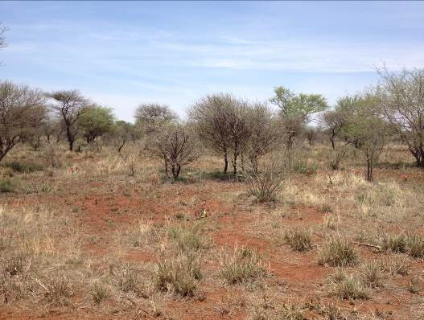

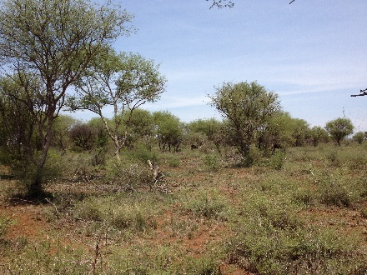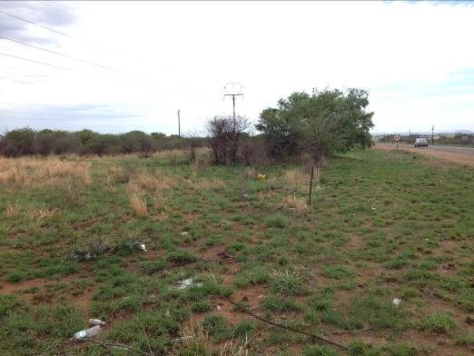

Environmental Management Plan

November 2013

TABLE OF CONTENTS

1 INTRODUCTION 2
2 Generic VISUAL impact mitigation 3
3 Specific VISUAL impact mitigation 4
4 CONCLUSION 38

ESKOM MASA NGWEDI 765/400 KV
TRANSMISSION LINE

KILOMETRES 1 - 40

ENVIRONMENTAL MANAGEMENT PLAN

VISUAL IMPACT ASPECTS – GENERIC AND SPECIFIC

FINAL DRAFT

INTRODUCTION

The erection of a transmission line is a phased operation which has distinct sequential activities. Each activity’s actions result in change to the immediate and local natural and social environment.

This Environmental Management Plan (EMP) focuses on those activities which affect the visual character, ambience and sense of place of the existing receiving environment. Both the construction and operation stages of the transmission line are addressed.

Visual aspects that are generic and specific for the construction and operation stages for individual tower locations are identified and mitigation procedures are described.

The vegetation of the majority of the study area forms part of the savanna biome and is characterised by mainly Mixed Bushveld with some sections of Clay Thorn Bushveld. The vegetation is relative more disturbed by farming and overgrazing that the area further to the north.

The topography of the area comprises mostly undulating to flat plains but also has a mountainous character in the vicinity of the Pilanesberg that lies immediately to the west of the southern section of the lin. Nortite hills protrude from the flat landscape from time to time.

This landscape and topography is typical of the south western Limpopo Province / northern NW Province. The implications from a visual impact perspective is that the visual mitigation of transmission towers over the plains can only rely on distance from the receiver and the woodland bushveld as a visual screen when close to the viewer.

Generic VISUAL impact mitigation

The phased sequential activities, their visual impacts and their generic visual mitigation aspects are identified and set out in Table 1, General Visual Aspects and Mitigation.

Eskom’s Generic EMP addressed a comprehensive list of environmental impact aspects. Some of these have visual or aesthetic impacts on the existing environment. In some cases attention to these will also address visual impact mitigation. For instance, measures to prevent soil erosion will prevent visual degradation of the landscape, particularly on sloping landforms. It is not the intention to repeat in detail the common impact mitigation measures. It is, however, important to describe the visual impact result and what measures are required to reduce the negative visual affects.

The landscape of the Bushveld through which the transmission line is aligned, is generally described as extensive large undulating to flat plains and gentle valleys vegetated by dense, short bushveld to a rather open tree savannah. The visual intrusion of regularly spaced (200 m) 35 m tall transmission towers and the lines in such a landscape is significant on the visual character and sense of place of the close (500 m) and medium (1 km) surrounding areas. Views into or of the landscape are therefore permanently changed.

The alignment therefore of the transmission route provides the primary opportunity to limit the visual intrusion. The alignment of the route should favour flat ground that is near to or which is back dropped by a taller landform.

The secondary opportunity to ameliorate visual intrusion in the landscape is related to the construction stage of the project and it is necessary to ensure the short term activities do not result in long term scars or visual abnormalities in and on the landscape. The visual impacts are short term, but can result in long term localised visual degradation. It is therefore important to implement immediate effective mitigation.

The final opportunity to manage the mitigation of the visual impacts is during the operation stage of the project. This will be achieved by quarterly inspections of the rehabilitated areas. The repair of degrading rehabilitated areas will need to be immediate and effective.

- Align the route through the lower lying landforms and off the ridge lines. This is to maximise the backdrop screening effect of the topography that will reduce presenting the transmission line in silhouette. It is recommended that the alignment be closer to the edges of ridges and mountains than down the centre of the valleys.
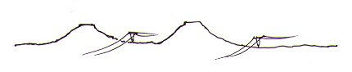
- Plan the route so that the route crosses existing main roads is as close to 90° as possible as this will reduce the time that the line is in the viewshed of the passing motorist / viewer.
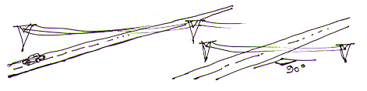

- Avoid aligning the route along the top of ridges. Should it be necessary to cross a ridge it is preferable to cross directly over rather than at an angle. This will limit the extent that the transmission line will be visible. Attempt to cross over at a depression such as a neck or saddle in the ridge. This will limit the visual effect of any pylon standing proud above the ridgeline.
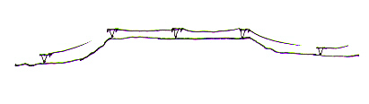
- Align the route, where possible, away from any main road where the two are parallel in relative pristine areas to where distance will mitigate the impact or to where the topography will form a screening backdrop.

- Avoid a route that will dominate any tourism facility, residential estate, lodge or farmsteads’ view.
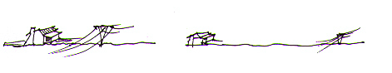

- Position the towers on a midslope of a landform that rises to a plateau and koppie so that the plateau or koppie will form a background to the line.
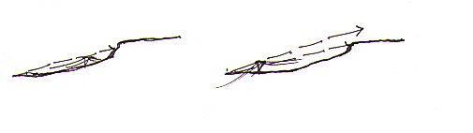

- Avoid aligning the route through densely vegetated or forestry areas where the line will require that a servitude will need to be cleared. Rather align it to the edge of the plantation / vegetation community where the cut line will not be as visually obvious. Avoid clearing servitudes or access roads that will run alongside the line(s). Rather use existing roads and tap off the road to gain access to the pylons.

- When a new line runs parallel and close to an existing line place the transmission towers at the same spacing as the existing line where possible.
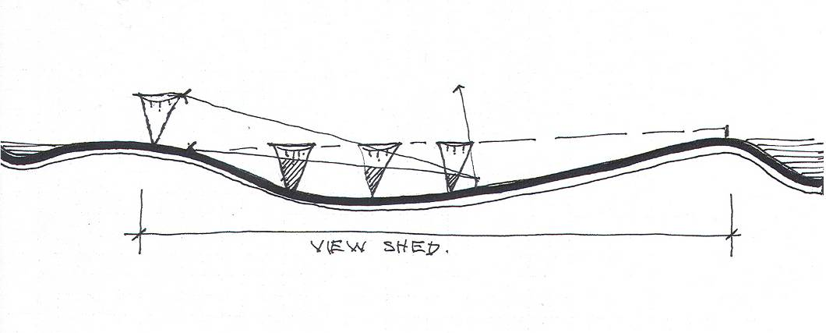
- Illustration of how view positions and topography affect intensity of visual impact.
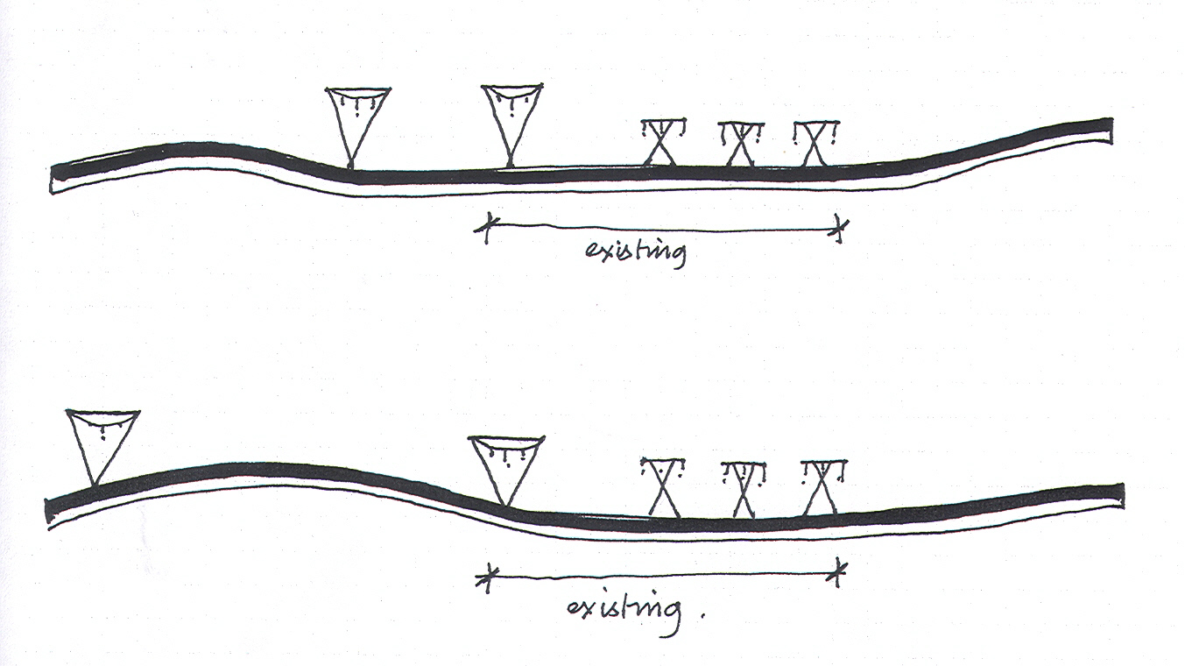
- Adding a new transmission line to a number of existing lines significantly increases the visual impact of the whole.
- Moving the new transmission line away lessens the visual impact of the line relative to the existing ones.

- The grey colour of the galvanising on the transmission towers is suitably neutral and helps to blur the form against landscape and sky.

The visual impact during construction will have a medium significance and little can be done about reducing the effect since the works cannot be screened.

The mitigation measures for the transmission line during operation will need to focus on effective rehabilitation of the construction corridor and work sites. These specifications must be explicit and detailed and included in the contract documentation (Environmental Management Plan) so that the tasks can be costed and monitored for compliance and result.

The galvanising of the pylon should be allowed to weather to a matt grey finish rather than be painted silver, as is often the case. This allows the structures to blend in with the existing environmental colours more readily than the silver which is highly reflective especially early morning and late afternoon. Should it be necessary to paint, it is recommended that a neutral matt finish be used.

Sculpturing or shaping the cut and fill slopes of access roads to angles and forms that are reflected in the adjacent landscape can reduce the visual impact. By blending the edges with the existing landforms the visual impression made, is that the project component has followed a natural route provided by the landscape, rather than been ‘engineered’ through the landscape.

For access / service roads and servitudes avoid straight edges and corridors. These lines should complement the landscape through which they pass (Litton, 1980).

Special attention should be focussed on the width of servitude actually required for the construction and operational phases. There is a tendency to make these servitudes wider than necessary and access roads built to a higher engineering specification than required for a single lane 4x4 maintenance vehicle track.

Should it be required vegetation stripping of servitude corridors should be done in a manner where the edges are organic (non-geometric) or curvilinear rather than straight or sharp edged. It is recommended that where possible only selective removal of vegetation be done to avoid the broad visual swath a stripped servitude can cause through the vegetation.

It is essential that all cut and fill slopes, as well as all areas disturbed by construction activity, are suitably topsoiled and vegetated as soon as is possible after final shaping. The progressive rehabilitation measures will allow the maximum growth period before the completion of the project.

All areas affected by the construction works will need to be rehabilitated and re-vegetated. This includes the areas beyond the works area such as temporary access roads, construction campsites, workers campsites, laydown areas, etc.

The special conditions of contract must include for the stripping and stockpiling of topsoil from the construction areas for later re-use. Topsoil is considered to be at least the top 300 mm of the natural soil surface and includes grass, roots and organic matter. The areas to be cleared of topsoil should be all areas that will be covered by structures, roads and construction camps. The presence of degraded and disused roads and areas left over after development that are not rehabilitated, could present a high perceptual visual impact. These areas should be topsoiled and re-vegetated.

All existing large trees that fall outside the earthworks area must be retained. These will assist in softening the forms of the structures and obscure views to them.

Dust generated by construction activity and the haulage of materials and equipment will need to be suppressed by regular wetting. The importance of suppressing the visual aspects of dust cannot be over-stressed since the visibility will generate the impression of a polluting industry.

Specific VISUAL impact mitigation

The following identifies specific transmission towers, the environmental issues and the mitigation requirements. Refer to Table 2, Specific Visual Aspects and Mitigation.

Where it is anticipated that visual qualities of the landscape are going to be particularly altered by the tower, whether it be the position or the result of the erection requirements, it is necessary to identify that location and to prescribe what mitigation is required.

In this way the specific visual mitigation relates to an identified condition that will result in short term or long term visual impacts. If these are not addressed in time and in a particular manner, persistent irreversible long term visual impacts will result.

The specific mitigation measures therefore address location specific conditions that are not covered by the generic mitigation measures.

- The consequences of not addressing the visually specific mitigation aspects will result in the transmission towers and line not having been “fitted” or integrated into the landscape setting.

- A landscape that is sensitive to visual change caused by tall linear elements requires attention to visual integration issues so that the intrusion on a macro and a micro scale is reduced.

- Table 1: Generic Visual Aspects and Mitigation

CONSTRUCTION PHASE | ENVIRONMENTAL ISSUE | MITIGATION REQUIREMENTS
1. Access road selection and construction | - Cut and fill section of access road on sloping landforms have long term scars that visually alter the natural landscape character.  - The painting or marking of rocks to identify locality or other information will disfigure a natural setting.  - The cutting down of bushes and trees to gain line of sight will damage the visual character of the particular site. | - Select alignments of road that minimise adjacent landform change such as cut and fill sections.  - In cut sections strip the top layer of soil (minimum 150 mm), stockpile upslope in windrows or in separate areas. This soil will include rock and vegetation.  - Shape cut and fill slopes to blend with adjacent landform by rounding off top cut and fill slopes, re-spreading soil and the placement of rocks packed or randomly placed to hold the replaced soil.  - Manage the surface runoff water from the road by not allowing its concentration. Provide regular diversion berms across the road to deflect water to undisturbed vegetated areas. The frequency, form and size of the berms will depend on the slope and material available. Material from the excavation for the foundations should be used to create the berms where possible. The excavation of material alongside the road for the berm formation shall not be allowed.  - No rocks or trees shall be painted. Marking shall be done by steel stakes with tags, if required.  - No trees or shrubs shall be cut. Offset stations / points shall be set to get around the line of site obstacle.
2. Foundation, excavation and casting of concrete | - The creation of platforms for towers on sloping landforms create scars that visually alter the landscape character. | - Remove and stockpile adjacent rock and the top 150 mm of soil on the upslope side of the excavation.  - Shape cut and fill slopes to blend with adjacent landform by rounding off the top edge of each.  - Re-spread stockpiled soil and pack rock on slopes to protect surface against erosion. This shall occur in all instances at the tower foundations.  - Remove from site all waste concrete. Surplus other material shall be used to create berms in the access road where required.
3. Delivery of steel for towers | - Visual degradation of areas caused by clearing vegetation for laydown of tower components. Long term visual scarring will result as vegetation is slow to re-grow in that environment. | - Select suitable level area with few rocks and large bushes. Cut vegetation if required. No clearing of vegetation or soil by grading with machinery shall be done.
4. Assembly of towers | - Visual degradation by establishing level area for tower assembly. | - Select suitable level area free of rock and large bushes. Cut vegetation (grass and Karoo shrubs), if required. No clearing of vegetation or soil by grading machinery shall be done.
5. Erection of towers | - Visual degradation caused by cranes and associated equipment churning up the vegetation and soil in the area. | - Select suitable level area free of rock and large bushes. Cut vegetation (grass and Karoo shrubs), if required. No clearing of vegetation or soil by grading machinery shall be done.
6. Cable stringing | - Visual degradation of areas where stringing machinery operated. The results in severely disturbed vegetation as traction of machines tear up grass and vegetation. | - Repair disturbed areas as soon as operation is complete. This to be done by cable stringing crew. Refer to specific rehabilitation requirements. Detail in the rehabilitation section of the EMP.
7. Rehabilitation | - General disturbance of land surface will degrade by erosion. Permanent visual scarring will result. | - Rip all areas compacted by machinery, smooth off and integrate disturbed areas visually into surrounding landform using spoil rock and stockpiled top layer of soil.  - Seed with approved indigenous species using commercial and harvested seed from the locality.  - Fence the area for two years to ensure game and livestock does not have access to areas that are on slopes and on erodible soils. Agree the fencing aspect with the landowner prior to erection.
OPERATIONAL PHASE | ENVIRONMENTAL ISSUE | MITIGATION REQUIREMENTS
1. Maintenance of visual intrusion mitigation aspects | - To ensure that all visual intrusion aspects dealt with during the construction stage are and remain effective. A quarterly assessment is required.  - All of the visual mitigation methods also relate to landscape impact mitigation such as erosion control, water runoff management. This is because, if these fail, they will have a negative visual implication. | - Inspect quarterly all rehabilitated areas.  - Immediately repair areas that show failure.  - Monitor rehabilitation progress and, where necessary, apply different techniques until stability of land is achieved.
Table 2: Specific Visual Aspects and Mitigation

765 kV Towers 342 to 376: No visual mitigation required
400 kV Towers 328 to 359 No Visual mitigation required

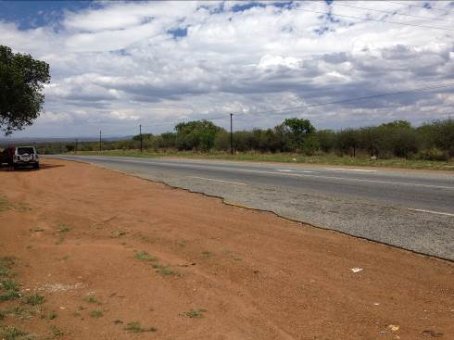

Photo 1 Road crossing of R 510 (765 kV pylon 377)

765 kV Tower 376 to 377 Ensure road crossing at right angles as far as possible
400 kV Tower 359 to 360 Ensure road crossing at right angles as far as possible

765 kV Towers 378 to 411: No visual mitigation required
400 kV Towers 361 to 390 No Visual mitigation required

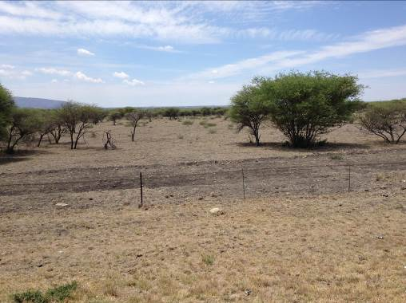

Photo 2 Road crossing R556 (765 kV pylon 411)

765 kV Tower 411 to 412 Ensure road crossing at right angles as far as possible
400 kV Tower 390 to 391 Ensure road crossing at right angles as far as possible

765 kV Towers 413 to 425: No visual mitigation required
400 kV Towers 392 to 405 No Visual mitigation required

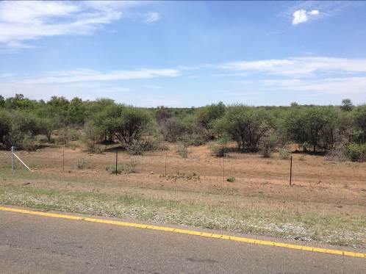

Photo 3 Road crossing of road from Sun City to Chaneng (765kV pylon 426)

765 kV Tower 425 to 426 Ensure road crossing at right angles as far as possible
400 kV Tower 405 to 406 Ensure road crossing at right angles as far as possible

765 kV Towers 427 to 436: No visual mitigation required
400 kV Towers 407 to 417 No Visual mitigation required

CONCLUSION

The transmission lines alignment through the landscape has been well fitted to the open generally flat areas. All road crossings have been done as close as to right angles as far as possible. Adherence to the general EMP conditions will further assist in reducing the visual impacts

